# INDEX

|  |  |  |
| --- | --- | --- |
| **Sr. No** | **Topics** | **Page NO** |
|  | Seminar Title | I |
|  | Certificate | II |
|  | Acknowledgement | III |
|  |  |  |
| 1 | History | 2 |
| 2 | Introduction | 6 |
| 3 | AR in Detail | 8 |
| 4 | [AR Example](#_Augmented_Reality_(AR)) | 14 |
| 5 | [AR Application](#_Augmented_Reality_(AR)_1) | 21 |
| 6 | [AR Diagrams or figures](#_Augmented_Reality_(AR)_2) | 24 |
| 7 | [Advantages & Disadvantages](#_Augmented_Reality_(AR)_3) | 25 |
| 9 | Enhancement of Topic/Future enhancement | 29 |
| 10 | References | 31 |

# History

**Not as old as you believe…**

Although many consider Augmented Reality (AR) a late 21st century development, the immersive technology has been with us much longer. Can't be that long, you might think right now. But you pretty sure did not think AR is about 60 years old, did you?

**AR is older than the Internet!**

Of course, it wasn't as advanced as we know it today. But still, quite an impressive resume! Today, AR in all its forms is almost everywhere and has become one of the biggest technology trends in the digital market. Snapchat filters, AR games like Pokémon Go, and augmented shopping are already part of our daily lives. And even after almost 60 years of enriching our reality, AR is far from retired.

**But when we speak of Augmented Reality, what do we mean?**

**Augmented Reality** gained its name, because it literally augments our reality – with information, visual graphics, sounds, animations and many more. AR enhances the physical world with virtual elements that interact or blend in with the given environment. It is specifically useable on mobile devices like smart phones or tablets, using the camera view of each device to place the augmented extensions. But speaking of AR as a final development would be entirely wrong: The technology continues to be constantly progressed and manifests its high standard of innovation as a permanent part of a digital future. Nowadays there are plenty of AR companies as well as AR development companies and even more using AR in digital Marketing.  And while all of us are constantly racing towards the future, we want to take a minute and appreciate the past and the long way AR has gone.

**AR in the 60’s**

* **1968: ‘Sword of Damocles’ – the Ancestor of AR Glasses**

AR found its origin in the 1960’s, when pioneer Ivan Sutherland developed the ‘Sword of Damocles’ at the University of Salt Lake City in the United States. The device was a head-mounted three-dimensional display functioning as a pair of glasses to view images in 3D.

**AR in the 90’s**

* **1990: Happy Birthday to the expression ‘Augmented Reality’!**

Boeing researchers Tom Caudell and David Mizel invented a head-mounted display for aircraft construction called ‘Augmented Reality’

* **1992: First fully immersive AR Training System**

Louis Rosenburg created the AR tool ‘Virtual Fixtures’ at the US Air Force Research Laboratory, a virtual flying training for Air Force pilots.

* **1994: AR in Theatre and Entertainment**

Writer and producer Julie Martin was the first to integrate AR to a theatre production. Named ‚Dancing in Cyberspace‘, the show featured acrobats dancing alongside projected virtual objects on the stage.

* **1998: AR in Sports**

A live NFL game was firstly broadcasted with the virtual ‚1st & Ten‘ graphic system, also known as the yellow yard marker that marks actions on the field.

* **1999: AR in Navigation**

NASA’s X-38 spacecraft was an AR system to assist in providing better navigation during test flights with displayed map data right on the pilot’s screen.

**Welcome to the new Century: AR in the 00’s**

* **2000: AR in Games**

The first AR Game ‘AR Quake’ was launched, where players wore a head mounted display and a backpack containing a computer

* **2005: Debut of AR Apps on Phones**

The very first AR app for the phone was called AR Tennis and could be played by two persons on a Nokia Phone.

* **2008: AR in commercial Print Ads**

BMW was the first automotive company to use AR technologies in a magazine ad to promote the BMW mini as virtual 3D model.

* **2009: First AR enabled magazine**

Esquire Magazine used AR to make their magazine come alive and made actor Robert Downey Jr. appear after scanning the cover.

**AR in the 2010’s**

* **2013: First AR enabled magazine**

Volkswagen debuted the MARTA app which gave step-by-step repair instructions within the AR service manual showing that AR trainings could be applied to all kinds of industries

* **2014: Release of Google Glass**

The wearable AR technology worked via internet and voice control enabling to access Google apps as Google Maps, Gmail, and more.

* **2015: AR on Social Networks**

Snapchat implements AR Filters, quickly followed by other social networks like Facebook or Instagram in 2016 and 2017.

* **2016: Release of Pokémon Go**

The popular location-based AR game by Nintendo and Niantic put AR on the mainstream map.

* **2016: Microsoft published Microsoft HoloLens**

Microsoft published its version of wearable AR technology with more advanced features than the Google Glass, followed by Microsoft HoloLens. The greatest benefit? It allowed users to scan their environment and create own AR experiences.

* **2017: AR changing the Retail industry**

IKEA released an AR app that allows customers to virtually preview their furniture options before making a purchase and encouraged other industries to do the same.

* **2017/18: Google and Apple introduced their own AR development kits**

In 2017/18 AR Reality has had its largest boost in public awareness, as both Apple and Google released their own Augmented Reality development kits for the platforms iOS and Android. The names ARKit and ARCore SDK are until today indispensable in the industry.

# Introduction

Technology has advanced to the point where realism in virtual reality is very achievable. However, in our obsession to reproduce the world and human experience in virtual space, we overlook the most important aspects of what makes us who we are—our reality. Yet, it isn’t enough just to trick the eye or fool the body and mind. One must capture the imagination in order to create truly compelling experiences.

On the spectrum between virtual reality, which creates immersible, computer-generated environments, and the real world, augmented reality is closer to the real world. Augmented reality adds graphics, sounds, haptics and smell to the natural world as it exists. You can expect video game to drive the development of augmented reality, but this technology will have countless applications. Everyone from tourists to military troops will benefit from the ability to place computer-generated graphics in their field of vision.

Augmented reality will truly change the way we view the world. Picture yourself walking or driving down the street. With augmented reality display, which will eventually look much like a normal pair of glasses, informative graphics will appear in your field of view and audio will coincide with whatever you see. These enhancements will be refreshed continually to reflect the movements of your head. In this article, we will take a look at this future technology, its components and how it will be used.

With the introduction of Augmented reality (AR) as being coined the term in the early nineties, we were able to apply virtual objects within physical reality. Combining techniques of Sutherland/Sproull’s first optical see-through Head Mounted Display (HMD) from the early 1960’s with complex, real-time computer-generated wiring diagrams and manuals. Both were registered with each other and manuals were embedded within the actual aircraft for intensely detailed procedures.

Augmented reality (AR) refers to computer displays that add virtual information to a user’s sensory perceptions. Most AR research focuses on see-through devices, usually worn on the head that overlay graphics and text on the user’s view of his or her surroundings. In general it superimposes graphics over a real world environment in real time.

Augmented reality is far more advanced than any technology you’ve seen in television broadcasts, although early versions of augmented reality are starting to appear in televised races and football games. These systems display graphics for only one point view. Next-generation augmented reality systems will display graphics for each viewer’s perspective.

# AR Detail

Augmented Reality (AR) is a technology that overlays digital content (graphics, text, audio, and video) on real-world images using mobile devices, PCs, or glasses, which have an integrated camera and specialized software

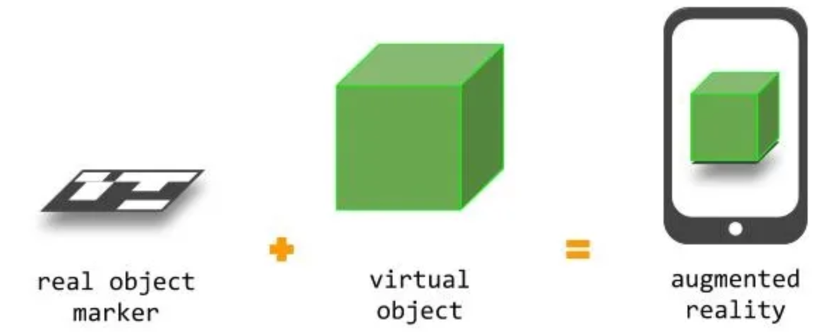

Augmented Reality = **real object marker** + virtual object

**PROPERTIES:**

AR system have to following properties:

1. Combines real and virtual objects in a real environment.
2. Runs interactively, and in real world.
3. Registers (aligns) real and virtual

**Types of Augmented Reality**

AR superimposes digital imagery into your field of vision, meaning it partially or fully replaces your un-augmented view. Within this basic interpretation, there are a few different types of augmented reality. Here's what to know.

**Two main Types of AR**

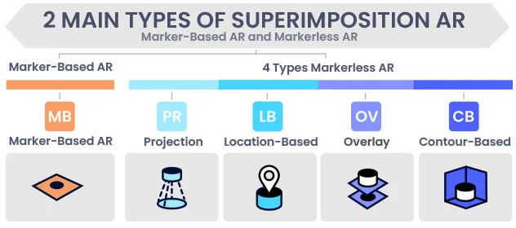

### Marker-Based AR

Maker-based AR works by scanning a marker which triggers an augmented experience (whether an object, text, video or animation) to appear on the device. It usually requires software in the form of an app, which enables users to scan markers from their device using its camera feed.

### Marker less AR

Marker-less AR offers the most control to the user as it allows the user to choose where they would like to place the content. It also allows real-life scale placement of the virtual augmented objects. These AR experiences are highly reliant on smart phone features such as sensors, camera, and processors. Marker-less AR can be split into:

* **Location-Based Augmented Reality:**

With location-based AR, the content is fixed to a specific physical space. It maps the real-world environment and defines visual positions in your surroundings. Once your device detects a match with the mapped location, it superimposes digital imagery accordingly. Pokémon GO is the most well-known example of location-based augmented reality.

### Projection-Based Augmented Reality:

As its name suggests, projection-based AR projects immersive light onto a flat surface to create 3D imagery. It then uses SLAM to detect human interaction with the augmentation. For instance, the projection-based AR can be used to create holograms that can be used for business purposes or just for fun.

* **Overlay AR:**

Overlay markerless AR replaces the un-augmented view of an object with an enhanced virtual image of the same item, complete with multiple visual perspectives. The Nextech Configurator is a great example of this technology. The product configurator tool allows users to change the color of a 3D product model as well as its arrangement. This lets customers customize how it visually looks and then place it within their room to see how it fits in their own space.

* **Contour-Based AR:**

Then there's contour-based augmented reality (or outlining AR), which leverages SLAM to outline the [silhouettes](https://www.researchgate.net/publication/350209223_Silhouettes_from_Real_Objects_Enable_Realistic_Interactions_with_a_Virtual_Human_in_Mobile_Augmented_Reality) of objects and simulate a realistic human interaction. For example, it might be used to develop a safe-driving application for nighttime, poorly-lit roads, heavy precipitation, and other low-visibility situations.

**How does Augmented Reality Work?**

The main components that make an AR system works are,

* **Display**

This corresponds to head mounted devices where images are formed. Many objects that do not exist in the real world can be put into this environment and users can view and exam on these objects. The properties such as complexity, physical properties etc. are just parameters in simulation.

* **Tracking**

Getting the right information at right time and the right place is the key in all these application. Personal digital assistants such as the plam and the pocket PC can provide timely information using wireless networking and Global Positioning System (GPS) receivers that constantly track the handheld devices.

* **Environment Sensing**

It is the process of viewing or sensing the real world scenes or even physical environment which can be done either by using an optical combiner, a video combiner or simply retinal view.

* **Visualization and Rendering**

Some emerging trends in the recent development of human-computer Interaction (HCI) can be observed. The trends are augmented reality, Computer supported cooperative work, ubiquitous computing, and heterogeneous user interface. AR is a method for visual improvement or enrichment of the surrounding environment by overlaying spatially aligned computer-generated information onto a human’s view (eyes).

The example of placing a cube:-

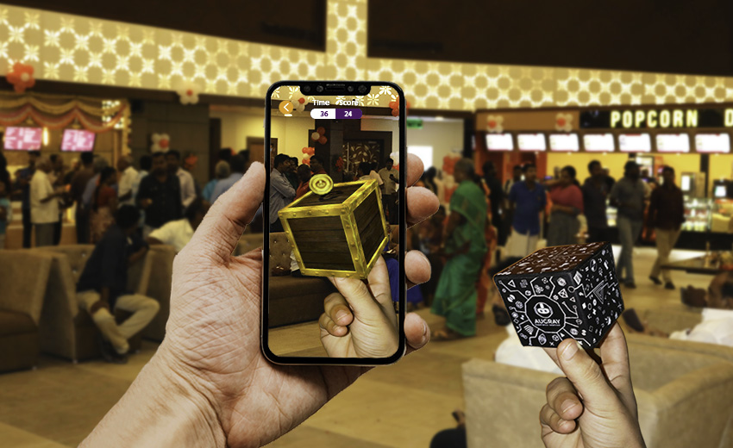

This is how AR work.

* **Pick A Real World Scene**

Real world. User’s view through the display of real world, showing a hand and a marker (tracker) without any overlaid graphics.

* **Add your Virtual Objects in it**

User’s view of the virtual world intended to overlay the view of the real world.

* Delete real world Objects.
* Not virtual Reality since Environment Real

**Developing And Designing For AR**

AR development platforms are platforms on which you can develop or code AR apps. Examples include ZapWorks, ARToolKit, MAXST for Windows AR and smart phone AR, DAQRI, SmartReality, ARCore by Google, Windows’ Mixed Reality AR platform, Vuforia, and ARKit by Apple. Some allow the development of apps for mobile, others for P.C., and on different operating systems.

AR development platforms allow developers to give apps different features such as support for other platforms such as Unity, 3D tracking, text recognition, creation of 3D maps, cloud storage, support for single and 3D cameras, support for smart glasses,

Different platforms allow the development of marker-based and/or location-based apps. Features to consider when selecting a platform include cost, platform support, image recognition support, 3D recognition, and tracking is a most important feature, support for third-party platforms such as Unity from where users can import and export AR projects and integrate with other platforms, cloud or local storage support, GPS support, SLAM support, etc.

The AR apps developed with these platforms support a myriad of features and capabilities. They may allow content to be viewed with one or a range of AR glasses that have pre-made AR objects, support for reflection mapping where objects have reflections, real-time image tracking, 2D and 3D recognition,

Some SDK or software development kits allow the development of apps by drag and drop method while others require knowledge in coding.

Some AR apps allow users to develop from scratch, upload, and edit, own AR content.

# Augmented Reality (AR) Example

1. **Snapchat**

Snapchat is a popular American multimedia messaging app. It is full of trendy and catchy filters. Applications like Snapchat follow a basic procedure of imposing these filters on the user’s face. Firstly, the face is detected with the help of artificial intelligence. Then, these filters are digitally overlaid on the face of the user. This imposing of the filters look extremely real and original with the help of augmented reality and artificial intelligence.

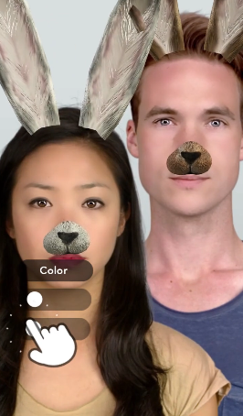

### ****Photography and Editing****

There are a lot of videos on the internet that show permanent body tattoos to be moving and changing colors. These videos are created with the help of augmented reality. The AR enriched software is downloaded on a device and an algorithm is generated in such a way that when the device’s lens scans the tattoo, a moving and color-changing video gets supplemented over its surface. Therefore, it is not the tattoo changing color but it is the virtual image of the video that gets wrapped over the real object.



1. **Hololens**

Hololens technology is developed by Microsoft. It allows the users to operate their gadgets by looking at the screen levitating in front of them. In order to establish an easy user-machine interface, it employs features such as air tap, head tracking, gesture command, voice command, etc. This technology makes use of several “environment understanding” sensors, a depth camera, and spatial mapping. Hololens is an ideal example of augmented reality and holds a promising future.



### ****Google ARCore****

Google ARCore is one of the best mobile apps available online that support augmented reality. It makes use of motion tracking, environmental understanding, and light estimation to generate virtual characters that perfectly blend with the physical world. These digital characters and stickers are produced with high quality and resolution that get digitally stick to the real-life surface. It also allows the 3D view of objects.



### ****Pokemon Go****

Pokemon go is one of the best examples of AR. It was first introduced in 2016 and within a few months, it got popular among people of all age groups. The notion was to create a game that would not only use digital technology but also employ physical involvement. The disadvantage that online games make people obese was successfully suppressed by this game. The main task of the game is to locate and catch a cartoon character virtually present in the surrounding. With the help of augmented reality, the game characters and the experience appear extremely authentic and genuine.



### ****Interior Decoration Apps****

We all want our home to be perfect, and we do everything to make it possible; however, making a permanent change such as changing the wall color, buying new furniture, etc. is risky because such huge changes can't be undone easily. This is why a lot of apps have been developed that allow us to virtually impose a picture over the physical objects to get an idea of how the change that we desire would look like after getting implemented. This provides us with the flexibility to try all available combinations and choose the best product. Asian paints, IKEA place, etc. are some examples of augmented reality-based interior decoration apps.



### ****AR Maintenance****

An augmented reality-equipped maintenance system provides remote assistance to the user. It provides a detailed procedure to repair certain machinery by running a virtual show and by highlighting the parts of the machinery that need fixing. These tactics are very helpful to beginners that have limited knowledge and experience in repair and renovation. These applications are often used in the automobile industry to assist consumers in regular servicing of the vehicles.



### ****Google Glass****

Google Glass is a gadget that eliminates the need to continuously hold a cell phone in hand, in order to operate it. It allows us to access the phone virtually with the help of voice commands and gestures. Google Glass can be connected to the phone with the help of Wi-Fi or Bluetooth. It can perform various operations such as access the internet, manage phone calls and messages, take a picture, record a video, etc. This hands-free operation makes the mobile phone seem almost real, and it is possible only with the help of augmented reality.



### ****Google Street View****

Traditional maps have certain limitations when it comes to have detailed information about a place. On the other hand, digital maps can be accessed easily on mobile phones. Also, they provide us with a bonus feature of zoom in. Street view is an upgraded feature of google maps that allows us to move a step further in the direction of advancement. With the help of street view, the direction arrows and markings can be seen live in front of us. It makes use of augmented reality to superimpose the information over real-life objects. Thereby, making the maps easy, comfortable, and advanced to use.



### ****Pitch Summary in Cricket****

A Pitch map or pitch summary is used to trace the bowling length, whether it is short, long, or a yorker. It also displays the number of shots that went ‘on-side’ and ‘off-side.’ The distance and direction of boundaries are also represented with the help of a pitch map. Different colors are used to represent different aspects of the current over. These lines and marks are not present on the actual field, but they seem real because a digital augmentation is overlaid using AR technology.

### ****Neurosurgery****

Augmented Reality finds its prime application in the medical domain. During surgeries, neurosurgery to be precise, AR serves to be the perfect assisting partner as it highlights the blocked and damaged nerves digitally. This helps the doctors to easily operate on the affected nerves and avoid any possibility of human error.



1. **ROAR**

ROAR is another one of the best AR apps also targeted to business owners. There are tons of ways to use it: create an AR-powered online store accessible when customers scan product packaging at home, incorporate AR into print ads, and even see which products and categories are most popular when experienced through AR.

On the consumer side, the app enhances both in-store and at-home brand experiences by providing deeper, more engaging content and information about the products they’re interested in. They can browse reviews, look at pricing, and even purchase the product in-app.

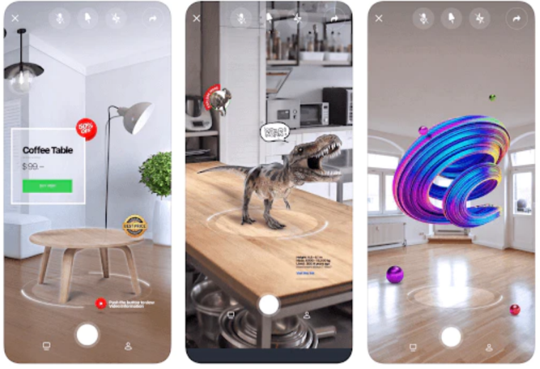

# Augmented Reality (AR) Application

The Augmented Reality technology has many possible application in a wide range of fields, including entertainment, education, medical, engineering and manufacturing.

It is expected that other potential areas of applications will appear with the dissemination of this technology.

1. **Medical Training**

This technology is adopted by medical students to assist them in practicing surgery within a controlled environment. Visualizations help in demonstrating complex medical conditions to patients. Augmented reality also facilitates enhanced sensory perception for surgeons thus helping in reducing the chances of risks in operations. Combined with an MRI or X-ray Augmented Reality can provide everything within a single view for the surgeon.

In the case of surgical applications, AR’s role in Neurosurgery remains most prominent. The technology’s capacity of developing a 3D image including exact coordinates of the brain, on top of the real anatomy of the patient becomes highly advantageous for the surgeon.

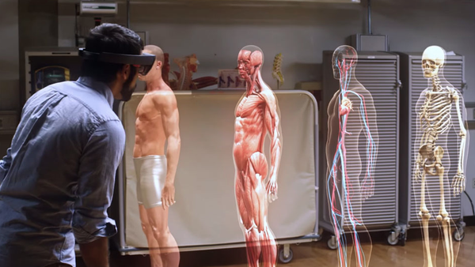

1. **Military**

A crucial application of Augmented Reality in the case of the military field is Heads-Up Display (HUD). In this technology, a transparent display is placed directly in the view of the fighter pilot. This display facilitates data for the pilot which includes information on the horizon line, airspeed, and altitude along with other imperative data.

Here “heads up” implies that owing to the display the pilot doesn’t need to look down towards the aircraft’s instrumentation to access the information he requires.

Another application is the Head-Mounted Display (HMD) which is adopted by ground troops. This crucial data including the location of the enemy can be displayed within the line of sight of the soldier. This technology is also adopted for developing simulations to assist in training.

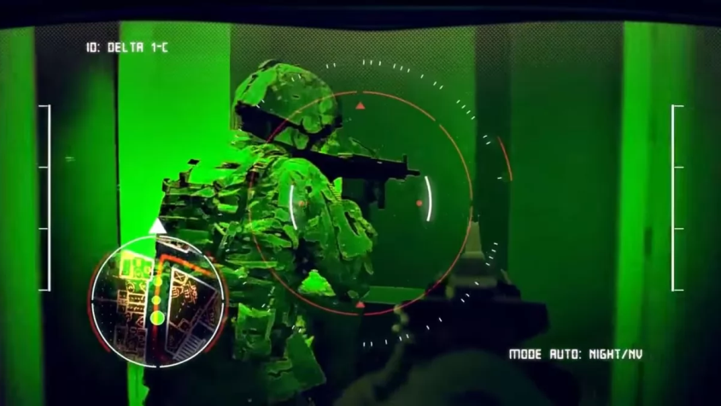

1. **Maintenance and Repair**

Augmented Reality enables its users to improve their field of view through real-time superimposed digital data. This enables users to garner data relating to an asset or gain access to step by step instructions on topics like how an asset can be repaired. A head-worn display can assist a mechanic in fixing an engine to see superimposed representation and data in his real view. The strategy could be displayed in a portion in the corner, and images of the vital tools can explain the specific movement the mechanic needs to carry out. The expanded reality framework can mark all the significant parts.

Complex procedural fixes can be broken down into a progression of basic steps. Through this technology, simulations can be utilized to prepare technicians, helping in cutting down on training costs, human errors, reducing the execution duration as well as breakdowns, and also cutting down on downtime.

1. **Gaming**

The recent developments in technology, as well as computing power, have paved the pathway for AR to establish itself within the gaming industry. With head-worn systems growing more affordable and computing power getting more portable, AR is highly enhancing the gaming experience. One such popular game is Pokemon Go, which was released in 2016 and went on to become the new trend.

In the game, players locate and capture Pokemon characters that pop up in the real world, be it on a sidewalk, in a fountain, maybe even in your own bathroom.

Various popular Android and iOS AR apps include Ingress, SpecTrek, Temple Treasure Hunt, Ghost Snap AR, Zombies, Run! and AR Invaders.

# Augmented Reality (AR) Diagrams or Figures

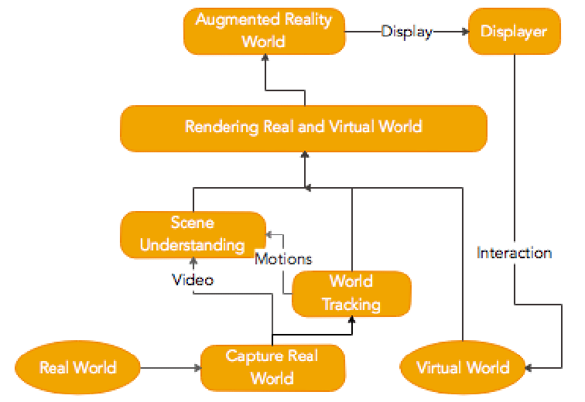

# Augmented Reality (AR) Advantages

Augmented Reality can help create an entirely new, interactive experience for users. Moreover, augmented reality offers a solution to the problem of being left out of the latest technological advances. The following advantages of AR make it a perfect tool for many sectors in the future.

1. **Enhanced Experience**

One of the benefits of Augmented Reality is that it can provide an enhanced experience. This means users will be able to take their phones and hold them up in front of a certain area, such as a building or natural landmark. The app then overlays information on top of what they are seeing, providing more depth than could otherwise be seen by just looking at something without AR technology like this.

You can see buildings from different angles and determine where you are standing through enhanced maps and positioning. For example, when used for navigation purposes, perhaps one perspective shows pedestrians crossing while another looks down onto the street below with arrows showing which direction drivers should go next.

1. **AR will be Easy to Use**

For mobile phone users, augmented reality is really easy to use. Just point your camera at an object, and the app will show you what it does with that particular item. So, for example, if you wanted to know how many calories are in a slice of pizza, all you would have to do is find an image of one on your screen and watch as the number pops up right next to it.

You can also look at something like furniture or clothing, so when you walk around your room or go shopping, you'll be able to see how well they fit into the space. It's easy for anyone who knows the way around their smartphone because all this information isn't just sitting there inside some clunky program; it's in fact, everywhere they look as far as the eye can see.

1. **Supports Business Activities**

AR is speculated to transform every business from housing to the retail market as the customers would be able to get more of the benefits and invest accordingly. Augmented Reality helps you with construction projects. The technology allows workers to identify and fix damaged parts of a building, structure or facility.

AR can also be used in the designing and remodelling processes; for instance, it is often more cost-effective than physical prototyping. This means companies have fewer upfront costs when they are designing new products. They will know what the final product looks like before manufacturing begins.

1. **Educational Advantages of Augmented Reality**

The pros of augmented reality include its potential as an educational tool that can provide rich content. The data is based on accurate GPS coordinates and provides navigation and directions without relying on paper maps.

Furthermore, there is greater access among students, educators and researchers to knowledge. For example, teachers can interact with students in classrooms globally while simultaneously teaching a lesson on the other side of the world using AR-enabled tools like Google Expeditions (Currently closed) or Aurasma.

1. **Improved Technology**

Augmented Reality is often used in the medical field for teaching methods and even surgery guidance. It has also been found that AR may help with learning disabilities such as dyslexia or ADHD by making it more fun and engaging than traditional methods can.

Augmented Reality can also make a person's job easier because they can have information on demand about their work at any time. This would enable them to alleviate the need of interrupting someone else for this type of request or wait until they get back into an office before checking out what was needed.

# Augmented Reality (AR) Disadvantages

Augmented reality is not as natural and intuitive as it appears. It's a lot of work to create an AR experience that feels organic for the user, and there are many different ways in which your product can be used incorrectly by consumers. The limitations of augmented reality include the costs majorly. Some other disadvantages of AR are as follows.

1. **Unaffordable**

Augmented reality is expensive to create, and some AR apps are too complex for the average user. The cost of an app can range from $0 up to around $100k; it all depends on how complicated you want your app or advertising campaign to be.

Not everyone has much capital to invest in augmented reality (AR) technology, so only certain large organizations have this advantage. Small scale companies would also be unable to afford this technology due to higher expenses.

1. **Privacy and Security Problems**

Augmented Reality can cause privacy or security concerns. This is rooted in AR making it difficult to discern between what's real and what's not, thus leading to a fear of being "tricked" by an attack.

For example, people using social media may be more likely to believe in false information if they're convinced their friends posted about it on Facebook.

1. **Promote Risky Behavior**

Augmented Reality is a technology that uses virtual overlay on the physical world. It can be used in games, entertainment, and many other ways. Augmented Reality has been around for decades, but it's only recently that they've had significant advances in technology to make them more mainstream, with smartphones and tablets providing AR experiences to consumers at an affordable price point.

1. **Addiction and Fatalities are major disadvantages of AR**

One of the cons of AR is that people share how addictive it can be to constantly check their phone for updates on the game or other apps. This addiction has been deemed as "smartphone fever" by psychologists and physicians.

Augmented reality can be a little challenging when it comes to real-life problems such as workplace accidents. For example, factory workers might lean over too far and end up injuring themselves due to vision being blocked by their glasses/contact lenses, such as leaning over while operating machinery at high speeds where there's no time to react.

1. **More health issues**

As the limitations of augmented reality are still in discussions, studies say the technology has many unprecedented health risks. The wearer of AR devices would immerse themselves into Virtual content which could lead to hearing loss, damage to eyes, even induce some behavioral change.

According to another study by Google daydream, users may tend to experience a virtual environment to be real leading to differences in how they perceive and process things. Such processes would lead to psychological problems like PTSD.

# Future of Augmented Reality

“The Future Of Augmented Reality.” included in industries like:

* **E-Commerce**

The retail & E-commerce software industry will stay ahead in the race when it comes to harnessing AI in the future. We’ll see its penetration in both --web and mobile apps. A normal-looking person may virtually dress up in sunglasses, jackets, footwear, and jewelry while putting the camera in a smartphone.

* **Digital Marketing**

This will be quite different and change the perception of customers. AR technologies will make the users experience more exciting when engaging with any brand. Marketing AR will likely be seen in packaging, on street signs, through gaming apps, and interactions with other products.

* **Geolocation**

Finding a nearby restaurant on your smartphone isn’t a new thing. But yes, AR will significantly deliver top-notch service. On a real-time basis, the advisories will surely come to the suggestions.

AR could benefit everything from real-time travel advisories to restaurant suggestions.

* **Healthcare**

Amidst this pandemic time the healthcare industry has ramped up, but still, there are many areas, by which, the modality of treatment can be transformed. Indeed, AR has the potential to change the healthcare sector.

It almost creates a 3D image by detaching users from reality that could be a driving force in the future.

* **Educational Resources –**

As we are completely into a virtual bowl. This will allow researchers to use AR in training situations. Military and healthcare industries, in particular, will be working on powerful AR simulations.

# References

[**https://svarmony.com/blog/history-of-ar**](https://svarmony.com/blog/history-of-ar)

[**https://www.nextechar.com/blog/what-are-the-different-types-of-augmented-reality**](https://www.nextechar.com/blog/what-are-the-different-types-of-augmented-reality)

[**https://arvrjourney.com/ar-101-a-brief-summary-part-1-a5b43fad8e4**](https://arvrjourney.com/ar-101-a-brief-summary-part-1-a5b43fad8e4)

[**https://en.wikipedia.org/wiki/Augmented_reality**](https://en.wikipedia.org/wiki/Augmented_reality)

[**https://scholar.google.com/**](https://scholar.google.com/)